Project Title: StudyBuddy AI – Smart Learning Assistant
Topic: AI Agent for Smart Education
Introduction
StudyBuddy AI is an intelligent learning assistant that helps students study effectively using Artificial Intelligence. It creates personalized study plans, explains difficult concepts, generates quizzes, tracks learning progress, and provides recommendations based on each student's performance. The agent acts as a virtual tutor that is available anytime and helps students prepare for exams in a systematic way.
Many students find it difficult to manage their study time and identify important topics. They often spend hours searching for notes, videos, and practice questions. StudyBuddy AI solves this problem by providing all learning resources in one place and creating a customized learning experience for every student.
The main objective of this project is to improve learning efficiency, reduce preparation time, and increase students' confidence through personalized guidance.
Problem Statement
Students face several challenges while preparing for examinations. Some students do not know which topics to study first, while others cannot identify their weak areas. Most online learning platforms provide the same content to everyone without considering individual learning abilities.
Because of this:
Students waste time searching for study materials.
They cannot track their progress properly.
They lose motivation due to poor planning.
Teachers cannot provide individual attention to every student.
StudyBuddy AI addresses these challenges by acting as an intelligent learning assistant that provides personalized study plans, quizzes, and continuous progress monitoring.
Objectives
Help students prepare for examinations.
Create personalized study schedules.
Generate AI-based quizzes.
Explain difficult topics.
Track learning progress.
Recommend suitable learning resources.
Improve academic performance.
Save students' time.
Increase learning efficiency.
Provide continuous feedback.
Agent Name
StudyBuddy AI
Goal of the Agent
The goal of StudyBuddy AI is to act as a personal virtual tutor that helps students learn more effectively by creating customized study plans, generating quizzes, monitoring performance, and recommending improvements based on individual learning needs.
Abstraction
The StudyBuddy AI agent observes information provided by the student, including subjects, syllabus, available study time, and examination dates.
The agent processes this information using AI algorithms and creates a personalized study timetable. During the learning process, it continuously evaluates the student's quiz performance and identifies weak topics. Based on this analysis, it modifies the study plan and recommends additional practice materials.
The agent continuously learns from student performance, making the learning experience smarter and more effective over time.
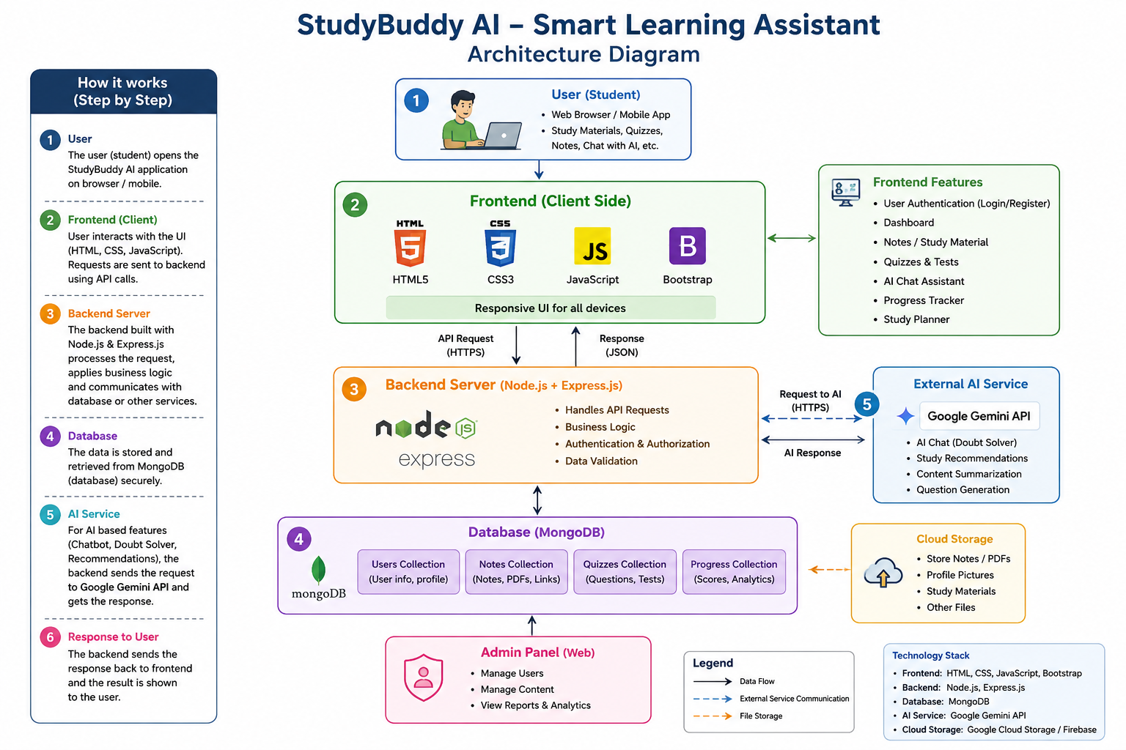
Uses of StudyBuddy AI – Smart Learning Assistant
StudyBuddy AI is a web-based learning platform that helps students study more effectively by combining learning resources, AI assistance, quizzes, and progress tracking in one place.
Uses of StudyBuddy AI
- Personalized Learning
  - Provides study materials based on the student's needs.
  - Helps students learn at their own pace.
- AI-Powered Doubt Solving
  - Answers students' questions instantly.
  - Explains difficult concepts in a simple way.
- Study Material Management
  - Stores notes, PDFs, presentations, and learning resources.
  - Allows students to upload, organize, and access materials anytime.
- Quiz and Assessment
  - Conducts online quizzes and mock tests.
  - Provides instant scores and feedback.
- Progress Tracking
  - Tracks completed lessons, quizzes, and study time.
  - Displays learning progress through reports and charts.
- Study Planner
  - Creates daily and weekly study schedules.
  - Sends reminders for exams, assignments, and deadlines.
- AI Content Generation
  - Generates summaries, important points, flashcards, and practice questions.
- Collaboration
  - Enables students to share notes and resources with classmates.
  - Supports group learning and discussions.
- Secure User Management
  - Provides secure login and registration.
  - Protects user data with authentication.
- Anywhere Access
  - Students can use the application from laptops, tablets, or mobile devices.

Applications of StudyBuddy AI
StudyBuddy AI can be used in many educational environments.
1. Schools
- Helps school students organize study materials.
- Assists teachers in assigning quizzes and tracking student progress.
2. Colleges and Universities
- Manages course notes, assignments, and study schedules.
- Supports project work and exam preparation.
3. Online Learning Platforms
- Provides AI-powered tutoring.
- Enhances online education with quizzes and personalized learning.
4. Competitive Exam Preparation
- Helps students prepare for exams such as GATE, GRE, UPSC, SSC, Banking, CAT, and others.
- Offers mock tests, AI explanations, and progress analysis.
5. Coaching Centers
- Enables instructors to upload study materials and monitor student performance.
- Conducts online assessments.
6. Self-Learning
- Supports independent learners with personalized study plans and AI guidance.
- Allows users to study anytime and anywhere.
7. Corporate Training
- Helps organizations deliver training materials to employees.
- Tracks learning progress and assessment results.
8. Distance and Remote Education
- Enables students to access learning resources from any location.
- Facilitates continuous learning without attending physical classes.

Benefits of StudyBuddy AI
- Improves learning efficiency.
- Saves study time through AI assistance.
- Enhances knowledge retention with quizzes and summaries.
- Encourages consistent study habits.
- Provides personalized learning support.
- Makes education more interactive and accessible.
- Simplifies progress monitoring for students and teachers.
- Supports learning from any device with an internet connection.

